Configuring Subversion with AD
- Install TortoiseSVN (SVN client tool).
- Install CollabNetSubversion-server (SVN server tool, this tool integrates the Apache).
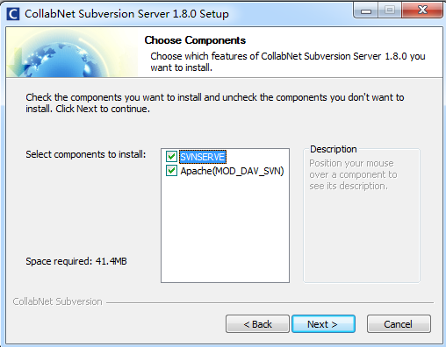

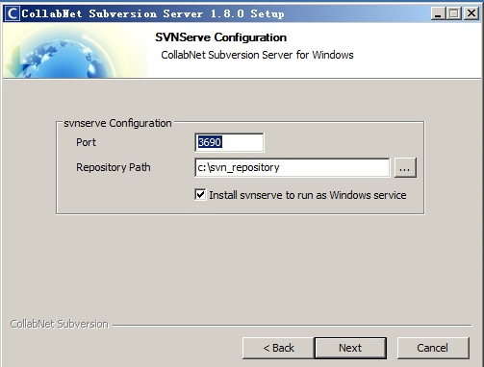

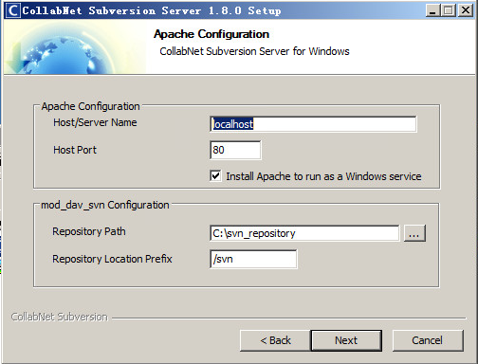
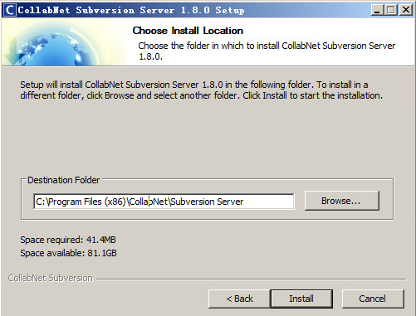
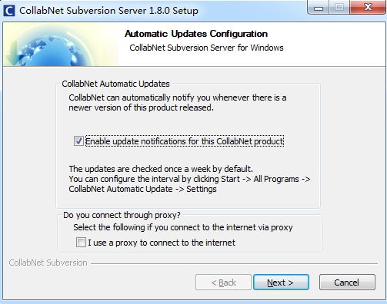

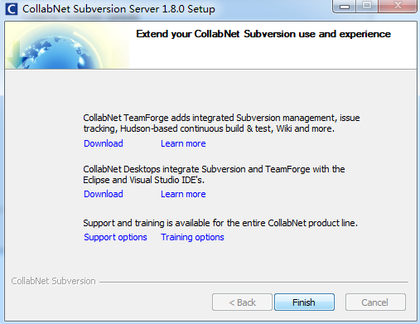

3. configuring
（1）Open the httpd.conf file (mine is located at C:\Program Files(x86)\CollabNet Subversion Server\httpd\conf\httpd.conf).

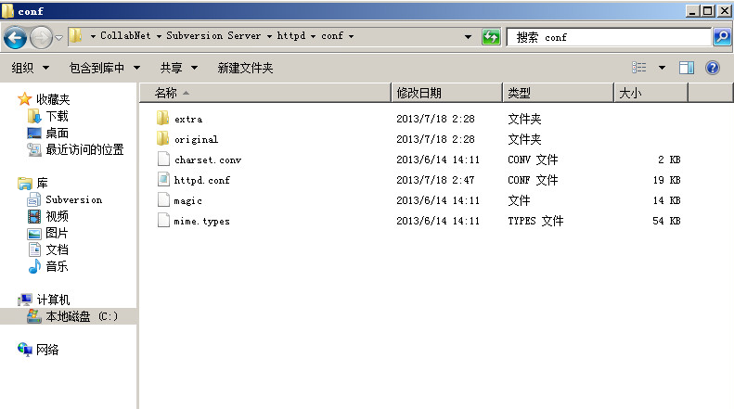
（2）Locate lines begin with “LoadModule …” , At the bottom of the existing LoadModule lines, add the following three lines:

LoadModule ldap_module modules/mod_ldap.so
LoadModule authnz_ldap_module modules/mod_authnz_ldap.so
LoadModule authz_svn_module modules/mod_authz_svn.so

Like the following picture：
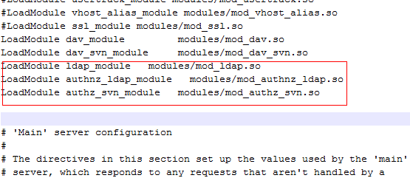

- look for <Location /svn>, just substitute for the following：

DAV svn
SVNParentPath C:/svn_repository
AuthzSVNAccessFile C:/svn_repository/access.txt
AuthzLDAPAuthoritative off
AuthType Basic
AuthBasicProvider ldap
AuthName "app-sg-isi"
AuthLDAPBindDN "CN=suhandy,CN=Users,DC=app-sg-isi,DC=i-sprint,DC=com"
#AuthLDAPBindDN "app-sg-isi\suhandy"
AuthLDAPBindPassword "password"
AuthLDAPURL "ldap://192.168.1.8:389/CN=Users,DC=app-sg-isi,DC=i-sprint,DC=com?sAMAccountName?sub?(objectClass=*)"
Require valid-user

Like the following picture：

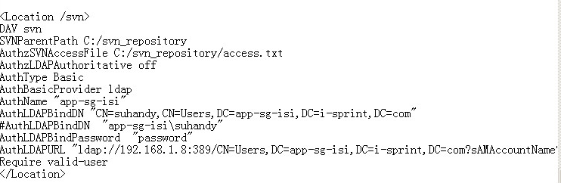

- Locate C:\svn_repository ,and new a folder”project1”，point right button :TortoiseSVN->Create repository here,
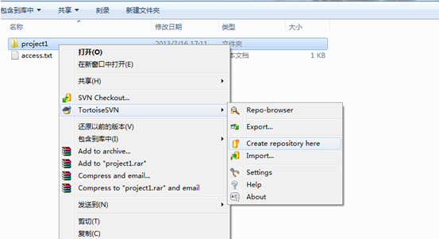
Choose “OK”。

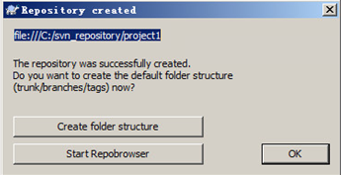

- Create a new file called “access.txt” where your repositories are located(mine is C:\svn_repository),for: to set up access for your repositories.

Like the following picture:


（6）Open your Services management console, Start the services.
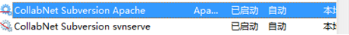

(7)import your project into the repository

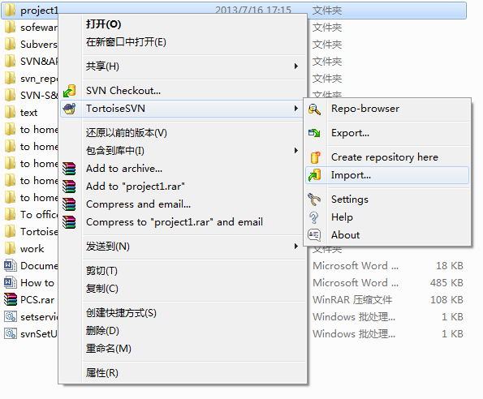
Enter the URL repository：
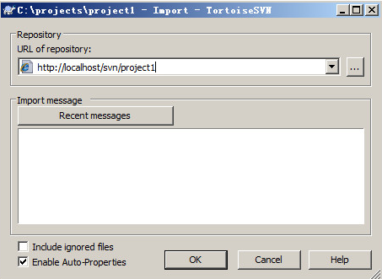

Enter the AD username and password：

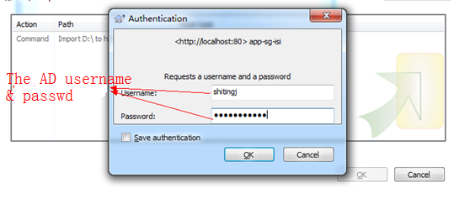
success：

