Spring security 例子教学

Spring Security3的使用方法有4种：
一种是全部利用配置文件，将用户、权限、资源(url)硬编码在xml文件中。
二种是用户和权限用数据库存储，而资源(url)和权限的对应采用硬编码配置。
三种是细分角色和权限，并将用户、角色、权限和资源均采用数据库存储，并且自定义过滤器，代替原有的FilterSecurityInterceptor过滤器，并分别实现AccessDecisionManager、InvocationSecurityMetadataSourceService和UserDetailsService，并在配置文件中进行相应配置。
四是修改spring security的源代码，主要是修改InvocationSecurityMetadataSourceService和UserDetailsService两个类。前者是将配置文件或数据库中存储的资源(url)提取出来加工成为url和权限列表的Map供Security使用，后者提取用户名和权限组成一个完整的 (UserDetails)User对象，该对象可以提供用户的详细信息供AuthentationManager进行认证与授权使用。该方法理论上可行，但是比较暴力，不推荐使用。
本文有两个例子，我在简单例子章节实现了第一种方法。在复杂例子章节实现了第二种和第三种方法组合使用的例子。简单例子通俗易懂，不再赘述。复杂例子及其使用和扩展，我将穿插详细的配置注释和讲解，包括整个程序的执行过程。

简单例子
创建web工程如下图所示：
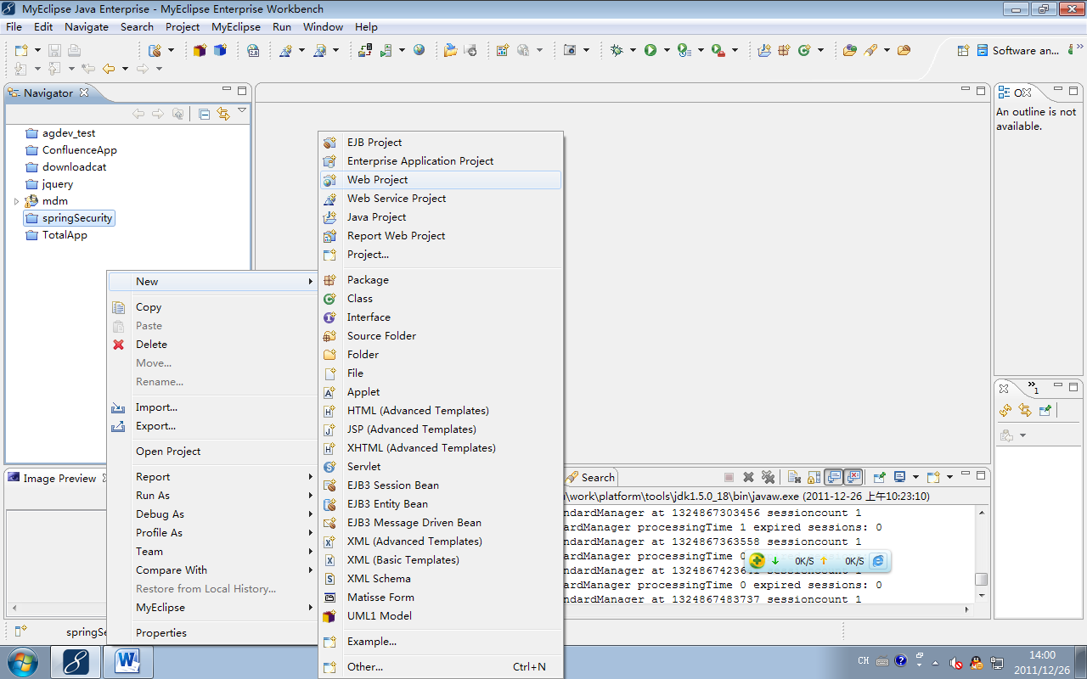
配置如下图所示：
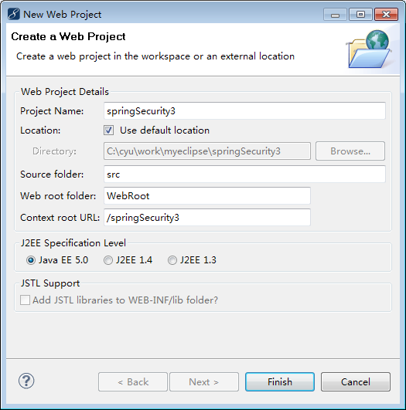
单击Finish即可。
把从spring网站下载的spring-security-3.1.0.RELEASE解压，并将其中的spring-security-samples-contacts-3.1.0.RELEASE.war解压，把WEB-INF\lib中的jar包拷贝到如下图所示：
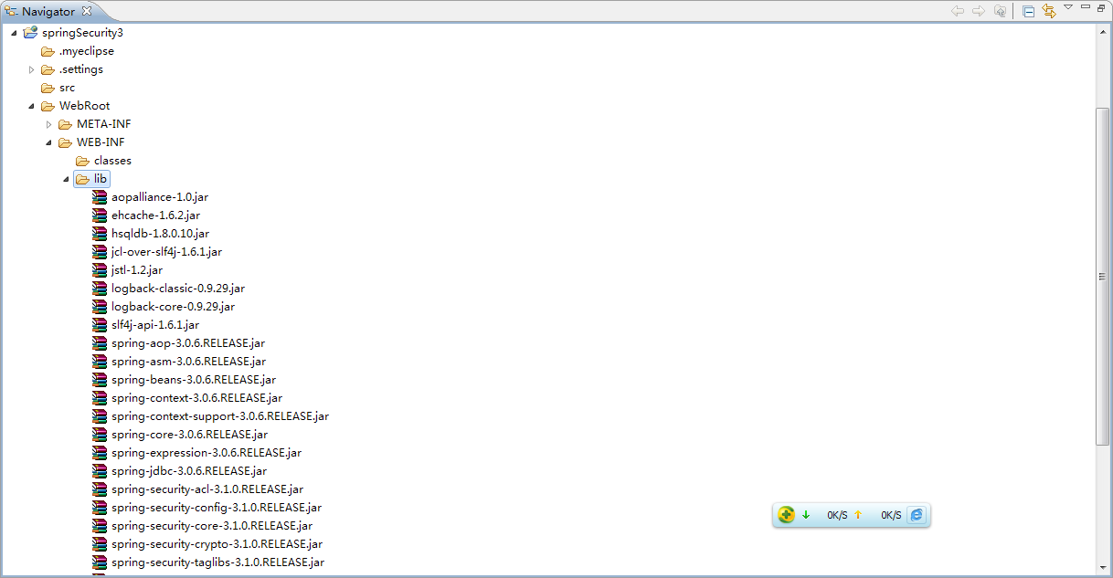
修改配置web.xml如下：
<?xmlversion="1.0"encoding="UTF-8"?>
<web-appversion="2.5"xmlns="http://java.sun.com/xml/ns/javaee"
xmlns:xsi="http://www.w3.org/2001/XMLSchema-instance"
xsi:schemaLocation="http://java.sun.com/xml/ns/javaee
http://java.sun.com/xml/ns/javaee/web-app_2_5.xsd">

<!--加载Spring XML配置文件 -->
<context-param>
<param-name>contextConfigLocation</param-name>
<param-value>
classpath:securityConfig.xml
</param-value>
</context-param>
<!-- Spring Secutiry3.1的过滤器链配置 -->
<filter>
<filter-name>springSecurityFilterChain</filter-name>
<filter-class>org.springframework.web.filter.DelegatingFilterProxy</filter-class>
</filter>

<filter-mapping>
<filter-name>springSecurityFilterChain</filter-name>
<url-pattern>/*</url-pattern>
</filter-mapping>

<!-- Spring 容器启动监听器 -->
<listener>
<listener-class>org.springframework.web.context.ContextLoaderListener</listener-class>
</listener>

<!--系统欢迎页面-->
<welcome-file-list>
<welcome-file>index.jsp</welcome-file>
</welcome-file-list>
</web-app>
在src中创建securityConfig.xml内容如下：
<?xmlversion="1.0"encoding="UTF-8"?>
<b:beansxmlns="http://www.springframework.org/schema/security"
xmlns:b="http://www.springframework.org/schema/beans"
xmlns:xsi="http://www.w3.org/2001/XMLSchema-instance"
xsi:schemaLocation="http://www.springframework.org/schema/beans http://www.springframework.org/schema/beans/spring-beans-3.0.xsd
http://www.springframework.org/schema/security http://www.springframework.org/schema/security/spring-security-3.1.xsd">

<!--登录页面不过滤 -->
<httppattern="/login.jsp"security="none"/>
<httpaccess-denied-page="/accessDenied.jsp">
<form-loginlogin-page="/login.jsp"/>
<!--访问/admin.jsp资源的用户必须具有ROLE_ADMIN的权限 -->
<intercept-urlpattern="/admin.jsp"access="ROLE_ADMIN"/>
<!--访问/**资源的用户必须具有ROLE_USER的权限 -->
<intercept-urlpattern="/**"access="ROLE_USER"/>
<session-management>
<concurrency-controlmax-sessions="1"error-if-maximum-exceeded="false"/>
</session-management>
</http>
<authentication-manager>
<authentication-provider>
<user-service>
<username="cyu"password="sap123"authorities="ROLE_USER"/>
</user-service>
</authentication-provider>
</authentication-manager>
</b:beans>
在WebRoot中创建login.jsp内容如下：
<%@pagelanguage="java"import="java.util.*"pageEncoding="UTF-8"%>
<!DOCTYPEhtmlPUBLIC"-//W3C//DTD HTML 4.01 Transitional//EN">
<html>
<head>
<title>登录</title>
</head>
<body>
<formaction="j_spring_security_check"method="POST">
<table>
<tr>
<td>用户:</td>
<td><inputtype='text'name='j_username'></td>
</tr>
<tr>
<td>密码:</td>
<td><inputtype='password'name='j_password'></td>
</tr>
<tr>
<td><inputname="reset"type="reset"></td>
<td><inputname="submit"type="submit"></td>
</tr>
</table>
</form>
</body>
</html>
在WebRoot中创建accessDenied.jsp，内容如下：
<%@pagelanguage="java"import="java.util.*"pageEncoding="utf-8"%>
<!DOCTYPEHTMLPUBLIC"-//W3C//DTD HTML 4.01 Transitional//EN">
<html>
<head>
<title>访问拒绝</title>
</head>
<body>
您的访问被拒绝，无权访问该资源！<br>
</body>
</html>
在WebRoot中创建admin.jsp内容如下：
<%@pagelanguage="java"import="java.util.*"pageEncoding="utf-8"%>
<!DOCTYPEHTMLPUBLIC"-//W3C//DTD HTML 4.01 Transitional//EN">
<html>
<head>
<title>My JSP 'admin.jsp' starting page</title>
</head>
<body>
欢迎来到管理员页面. <br>
</body>
</html>
修改index.jsp内容如下：
<%@pagelanguage="java"import="java.util.*"pageEncoding="UTF-8"%>
<%@taglibprefix="sec"uri="http://www.springframework.org/security/tags"%>
<!DOCTYPEHTMLPUBLIC"-//W3C//DTD HTML 4.01 Transitional//EN">
<html>
<head>
<title>My JSP 'index.jsp' starting page</title>
</head>
<body>
这是首页，欢迎<sec:authenticationproperty="name"/>!<br>
<ahref="admin.jsp">进入admin页面</a>
<ahref="other.jsp">进入其它页面</a>
</body>
</html>
添加工程如下图所示：
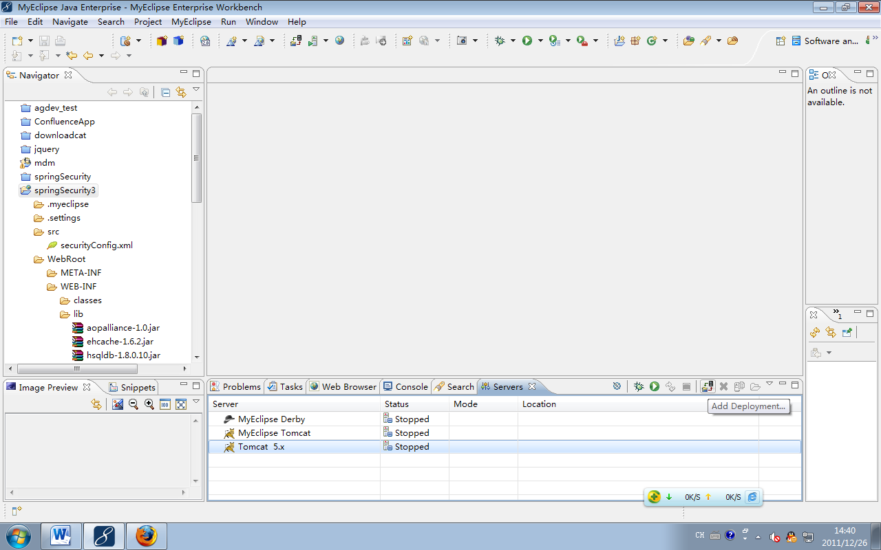
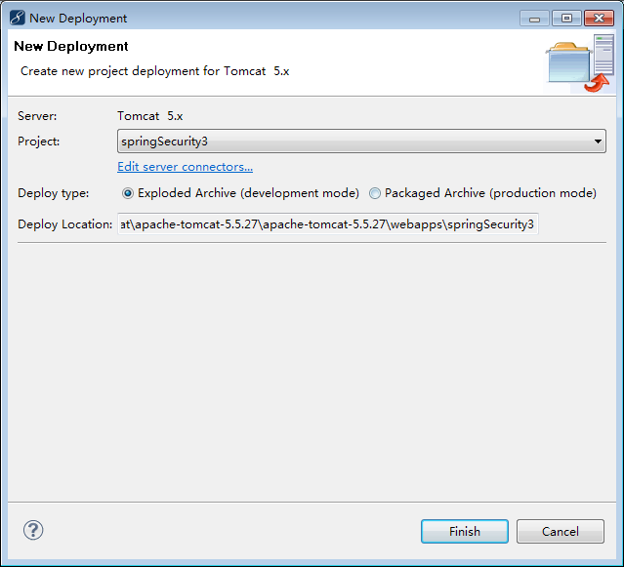
点击Finish即可，然后运行工程如下图所示：
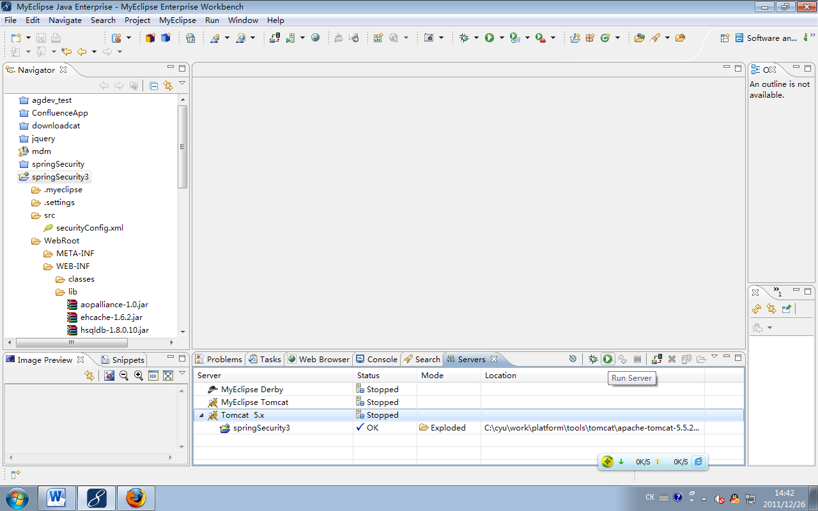
测试页面如下：
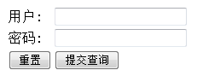
输入用户：cyu密码：sap123，然后回车：
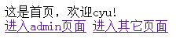
点击“进入admin页面”超链，得到如下图所示：


复杂例子
修改securityConfig.xml内容如下：
<?xmlversion="1.0"encoding="UTF-8"?>
<beans:beansxmlns="http://www.springframework.org/schema/security"
xmlns:beans="http://www.springframework.org/schema/beans"
xmlns:xsi="http://www.w3.org/2001/XMLSchema-instance"
xsi:schemaLocation="http://www.springframework.org/schema/beans http://www.springframework.org/schema/beans/spring-beans-3.0.xsd
http://www.springframework.org/schema/security http://www.springframework.org/schema/security/spring-security-3.1.xsd">

<!--登录页面不过滤 -->
<httppattern="/login.jsp" security="none"/>
<httpaccess-denied-page="/accessDenied.jsp">
<form-loginlogin-page="/login.jsp"/>
<!--访问/admin.jsp资源的用户必须具有ROLE_ADMIN的权限 -->
<intercept-urlpattern="/admin.jsp"access="ROLE_ADMIN"/>
<!--访问/**资源的用户必须具有ROLE_USER的权限 -->
<intercept-urlpattern="/**"access="ROLE_USER"/>
<session-management>
<concurrency-controlmax-sessions="1"error-if-maximum-exceeded="false"/>
</session-management>
<!--增加一个filter，这点与Acegi是不一样的，不能修改默认的filter了，
这个filter位于FILTER_SECURITY_INTERCEPTOR之前 -->
<custom-filterref="myFilter"before="FILTER_SECURITY_INTERCEPTOR"/>
</http>
<!--一个自定义的filter，必须包含authenticationManager,accessDecisionManager,securityMetadataSource三个属性，
我们的所有控制将在这三个类中实现，解释详见具体配置 -->
<beans:beanid="myFilter"class="com.aostarit.spring.security.MyFilterSecurityInterceptor">
<beans:propertyname="authenticationManager"
ref="authenticationManager"/>
<beans:propertyname="accessDecisionManager"
ref="myAccessDecisionManagerBean"/>
<beans:propertyname="securityMetadataSource"
ref="securityMetadataSource"/>
</beans:bean>

<!--验证配置，认证管理器，实现用户认证的入口，主要实现UserDetailsService接口即可 -->
<authentication-manageralias="authenticationManager">
<authentication-provider
user-service-ref="myUserDetailService">
<!--如果用户的密码采用加密的话
<password-encoder hash="md5" />
-->
</authentication-provider>
</authentication-manager>
<!--在这个类中，你就可以从数据库中读入用户的密码，角色信息，是否锁定，账号是否过期等 -->
<beans:beanid="myUserDetailService"
class="com.aostarit.spring.security.MyUserDetailService"/>
<!--访问决策器，决定某个用户具有的角色，是否有足够的权限去访问某个资源 -->
<beans:beanid="myAccessDecisionManagerBean"
class="com.aostarit.spring.security.MyAccessDecisionManager">
</beans:bean>
<!--资源源数据定义，将所有的资源和权限对应关系建立起来，即定义某一资源可以被哪些角色访问 -->
<beans:beanid="securityMetadataSource"
class="com.aostarit.spring.security.MyInvocationSecurityMetadataSource"/>
</beans:beans>
编写UrlMatcher接口，内容如下：
packagecom.aostarit.spring.security.tool;

publicabstractinterfaceUrlMatcher
{
publicabstract Object compile(String paramString);

publicabstractbooleanpathMatchesUrl(Object paramObject, String paramString);

publicabstract String getUniversalMatchPattern();

publicabstractbooleanrequiresLowerCaseUrl();
}
这个接口是以前spring版本中的，现在的spring版本中不存在，由于项目需要且使用方便，故加入到项目当中。
编写AntUrlPathMatcher类，内容如下：
packagecom.aostarit.spring.security.tool;

importorg.springframework.util.AntPathMatcher;
importorg.springframework.util.PathMatcher;

publicclassAntUrlPathMatcher
implementsUrlMatcher
{
privatebooleanrequiresLowerCaseUrl;
privatePathMatcherpathMatcher;

publicAntUrlPathMatcher()
{
this(true);
}

publicAntUrlPathMatcher(booleanrequiresLowerCaseUrl)
{
this.requiresLowerCaseUrl = true;
this.pathMatcher = newAntPathMatcher();

this.requiresLowerCaseUrl = requiresLowerCaseUrl;
}

public Object compile(String path) {
if (this.requiresLowerCaseUrl) {
returnpath.toLowerCase();
}

return path;
}

publicvoidsetRequiresLowerCaseUrl(booleanrequiresLowerCaseUrl) {
this.requiresLowerCaseUrl = requiresLowerCaseUrl;
}

publicbooleanpathMatchesUrl(Object path, String url) {
if (("/**".equals(path)) || ("**".equals(path))) {
returntrue;
}
returnthis.pathMatcher.match((String)path, url);
}

public String getUniversalMatchPattern() {
return"/**";
}

publicbooleanrequiresLowerCaseUrl() {
returnthis.requiresLowerCaseUrl;
}

public String toString() {
returnsuper.getClass().getName() + "[requiresLowerCase='" + this.requiresLowerCaseUrl + "']";
}
}
这个类是以前spring版本中的工具类，现在的spring版本中不存在，由于项目需要且使用方便，故加入到项目当中。
编写MyFilterSecurityInterceptor类，内容如下：
packagecom.aostarit.spring.security;

importjava.io.IOException;

importjavax.servlet.Filter;
importjavax.servlet.FilterChain;
importjavax.servlet.FilterConfig;
importjavax.servlet.ServletException;
importjavax.servlet.ServletRequest;
importjavax.servlet.ServletResponse;

importorg.springframework.security.access.SecurityMetadataSource;
import org.springframework.security.access.intercept.AbstractSecurityInterceptor;
import org.springframework.security.access.intercept.InterceptorStatusToken;
importorg.springframework.security.web.FilterInvocation;
import org.springframework.security.web.access.intercept.FilterInvocationSecurityMetadataSource;

publicclassMyFilterSecurityInterceptorextendsAbstractSecurityInterceptor
implements Filter {

privateFilterInvocationSecurityMetadataSourcesecurityMetadataSource;

/**
* Method that is actually called by the filter chain. Simply delegates to
* the{@link #invoke(FilterInvocation)} method.
*
* @param request
* theservlet request
* @param response
* theservlet response
* @param chain
* the filter chain
*
* @throwsIOException
* if the filter chain fails
* @throwsServletException
* if the filter chain fails
*/
publicvoiddoFilter(ServletRequest request, ServletResponse response,
FilterChain chain) throwsIOException, ServletException {
FilterInvocation fi = newFilterInvocation(request, response, chain);
invoke(fi);
}

publicFilterInvocationSecurityMetadataSourcegetSecurityMetadataSource() {
returnthis.securityMetadataSource;
}

public Class<? extends Object>getSecureObjectClass() {
returnFilterInvocation.class;
}

publicvoid invoke(FilterInvocation fi) throwsIOException,
ServletException {
InterceptorStatusToken token = super.beforeInvocation(fi);
try {
fi.getChain().doFilter(fi.getRequest(), fi.getResponse());
} finally {
super.afterInvocation(token, null);
}
}

publicSecurityMetadataSourceobtainSecurityMetadataSource() {
returnthis.securityMetadataSource;
}

publicvoidsetSecurityMetadataSource(
FilterInvocationSecurityMetadataSourcenewSource) {
this.securityMetadataSource = newSource;
}

publicvoid destroy() {
}

publicvoidinit(FilterConfig arg0) throwsServletException {
}

}
核心的是InterceptorStatusToken token = super.beforeInvocation(fi);会调用我们定义的accessDecisionManager:decide(Object object)和securityMetadataSource:getAttributes(Object object)方法。
编写MyInvocationSecurityMetadataSource类，内容如下：
packagecom.aostarit.spring.security;

importjava.util.ArrayList;
importjava.util.Collection;
importjava.util.HashMap;
importjava.util.Iterator;
importjava.util.Map;
importorg.springframework.security.access.ConfigAttribute;
importorg.springframework.security.access.SecurityConfig;
importorg.springframework.security.web.FilterInvocation;
import org.springframework.security.web.access.intercept.FilterInvocationSecurityMetadataSource;

importcom.aostarit.spring.security.tool.AntUrlPathMatcher;
importcom.aostarit.spring.security.tool.UrlMatcher;

/**
*
* 此类在初始化时，应该取到所有资源及其对应角色的定义
*
*/
publicclassMyInvocationSecurityMetadataSource
implementsFilterInvocationSecurityMetadataSource {
privateUrlMatcherurlMatcher = newAntUrlPathMatcher();
privatestatic Map<String, Collection<ConfigAttribute>>resourceMap = null;

publicMyInvocationSecurityMetadataSource() {
loadResourceDefine();
}

privatevoidloadResourceDefine() {
resourceMap = newHashMap<String, Collection<ConfigAttribute>>();
Collection<ConfigAttribute>atts = newArrayList<ConfigAttribute>();
ConfigAttributeca = newSecurityConfig("ROLE_USER");
atts.add(ca);
resourceMap.put("/index.jsp", atts);

Collection<ConfigAttribute>attsno = newArrayList<ConfigAttribute>();
ConfigAttributecano = newSecurityConfig("ROLE_NO");
attsno.add(cano);
resourceMap.put("/other.jsp", attsno);
}

// According to a URL, Find out permission configuration of this URL.
public Collection<ConfigAttribute>getAttributes(Object object)
throwsIllegalArgumentException {
// guess object is a URL.
String url = ((FilterInvocation)object).getRequestUrl();
Iterator<String>ite = resourceMap.keySet().iterator();
while (ite.hasNext()) {
String resURL = ite.next();
if (urlMatcher.pathMatchesUrl(resURL, url)) {
returnresourceMap.get(resURL);
}
}
returnnull;
}

publicboolean supports(Class<?>clazz) {
returntrue;
}

public Collection<ConfigAttribute>getAllConfigAttributes() {
returnnull;
}

}
对于资源的访问权限的定义，我们通过实现FilterInvocationSecurityMetadataSource这个接口来初始化数据。看看loadResourceDefine方法，我在这里，假定index.jsp这个资源，需要ROLE_USER角色的用户才能访问,other.jsp这个资源，需要ROLE_NO角色的用户才能访问。这个类中，还有一个最核心的地方，就是提供某个资源对应的权限定义，即getAttributes方法返回的结果。注意，我例子中使用的是AntUrlPathMatcher这个path matcher来检查URL是否与资源定义匹配，事实上你还要用正则的方式来匹配，或者自己实现一个matcher。
这里的角色和资源都可以从数据库中获取，建议通过我们封装的平台级持久层管理类获取和管理。
编写MyAccessDecisionManager类，内容如下：
packagecom.aostarit.spring.security;

importjava.util.Collection;
importjava.util.Iterator;

importorg.springframework.security.access.AccessDecisionManager;
importorg.springframework.security.access.AccessDeniedException;
importorg.springframework.security.access.ConfigAttribute;
importorg.springframework.security.access.SecurityConfig;
import org.springframework.security.authentication.InsufficientAuthenticationException;
importorg.springframework.security.core.Authentication;
importorg.springframework.security.core.GrantedAuthority;

publicclassMyAccessDecisionManagerimplementsAccessDecisionManager {

//In this method, need to compare authentication with configAttributes.
// 1, A object is a URL, a filter was find permission configuration by this URL, and pass to here.
// 2, Check authentication has attribute in permission configuration (configAttributes)
// 3, If not match corresponding authentication, throw aAccessDeniedException.
publicvoid decide(Authentication authentication, Object object,
Collection<ConfigAttribute>configAttributes)
throwsAccessDeniedException, InsufficientAuthenticationException {
if(configAttributes == null){
return ;
}
System.out.println(object.toString()); //object is a URL.
Iterator<ConfigAttribute>ite=configAttributes.iterator();
while(ite.hasNext()){
ConfigAttributeca=ite.next();
String needRole=((SecurityConfig)ca).getAttribute();
for(GrantedAuthorityga:authentication.getAuthorities()){
if(needRole.equals(ga.getAuthority())){ //ga is user's role.
return;
}
}
}
thrownewAccessDeniedException("no right");
}

publicboolean supports(ConfigAttribute attribute) {
// TODO Auto-generated method stub
returntrue;
}

publicboolean supports(Class<?>clazz) {
returntrue;
}

}
在这个类中，最重要的是decide方法，如果不存在对该资源的定义，直接放行；否则，如果找到正确的角色，即认为拥有权限，并放行，否则throw new AccessDeniedException("no right")。所有的异常建议平台统一进行封装并管理。
编写MyUserDetailService类，内容如下：
packagecom.aostarit.spring.security;
importjava.util.ArrayList;
importjava.util.Collection;

importorg.springframework.dao.DataAccessException;
importorg.springframework.security.core.GrantedAuthority;
importorg.springframework.security.core.authority.GrantedAuthorityImpl;
importorg.springframework.security.core.userdetails.User;
importorg.springframework.security.core.userdetails.UserDetails;
import org.springframework.security.core.userdetails.UserDetailsService;
import org.springframework.security.core.userdetails.UsernameNotFoundException;

publicclassMyUserDetailServiceimplementsUserDetailsService {

publicUserDetailsloadUserByUsername(String username)
throwsUsernameNotFoundException, DataAccessException {
Collection<GrantedAuthority>auths=newArrayList<GrantedAuthority>();
GrantedAuthorityImpl auth2=newGrantedAuthorityImpl("ROLE_ADMIN");
// auths.add(auth2);
if(username.equals("cyu")){
auths=newArrayList<GrantedAuthority>();
GrantedAuthorityImpl auth1=newGrantedAuthorityImpl("ROLE_USER");
auths.add(auth1);
auths.add(auth2);
}

// User(String username, String password, boolean enabled, booleanaccountNonExpired,
// booleancredentialsNonExpired, booleanaccountNonLocked, Collection<GrantedAuthority> authorities) {
User user = newUser(username,
"sap123", true, true, true, true, auths);
return user;
}

}
在这个类中，你就可以从数据库中读入用户的密码，角色信息，是否锁定，账号是否过期等。建议通过我们封装的平台级持久层管理类获取和管理。

- 整个程序执行的过程如下：
1、容器启动(MyInvocationSecurityMetadataSource：loadResourceDefine加载系统资源与权限列表)
2、用户发出请求
3、过滤器拦截(MyFilterSecurityInterceptor:doFilter)
4、取得请求资源所需权限(MyInvocationSecurityMetadataSource:getAttributes)
5、匹配用户拥有权限和请求权限(MyAccessDecisionManager:decide)，如果用户没有相应的权限，执行第6步，否则执行第7步
6、登录
7、验证并授权(MyUserDetailService:loadUserByUsername)
8、重复4,5

发布，测试页面如下：
输入用户：cyu密码：sap123，然后回车：
点击“进入admin页面”超链，得到如下图所示：
点击“进入其它页面”超链，得到如下图所示：

