Installation Guide for CE/PE server on Windows

Install P8 4.6 CE Server
Step 1. Install Basic software
Step 2. Install WAS 7007
Step 3. Install DB2 and Create database
Step4. Install CE Server
Step5. Config CE Servere
5.1 New Profile
5.2 Run Task 1:
5.2.1 WAS Console
5.2.2 Run task1
5.2.3 Test Connection On WAS Console
5.3 Run Task2:
5.4 Run Task3:
5.5 Task 4: Config LDAP
5.6 Install PE Client at CE server
5.7 Run Task5:Configure Bootstrap Properties
5.8 Run Task6: Deploy Application
Step 6. Validation
Step 7. Configure Domain
Step 8. Create Object Store ADOS
Step 9. Create Object Store ATOS
Install PE Server
Step1. Install PE
Step2. Install CE client
Step3. Modify the path for db2 jar
Step 4. Configure PE
Step 5. Validation

Install P8 4.6 CE Server

Step 1. Install Basic software
Download: \\9.181.141.168\c$\Inatallers administrator/Passw0rd

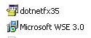
Note: Do not install WSE 3.0 on Windows 2008 .

Step 2. Install WAS 7007
Download: \\9.181.141.168\c$\Inatallers administrator/Passw0rd

Tips: Select Application Server during the installation.

Configure LDAP on WAS console:
2.1 Start WAS . Log in WAS console, navigate to Global Security Page, and then click Configure on the page.
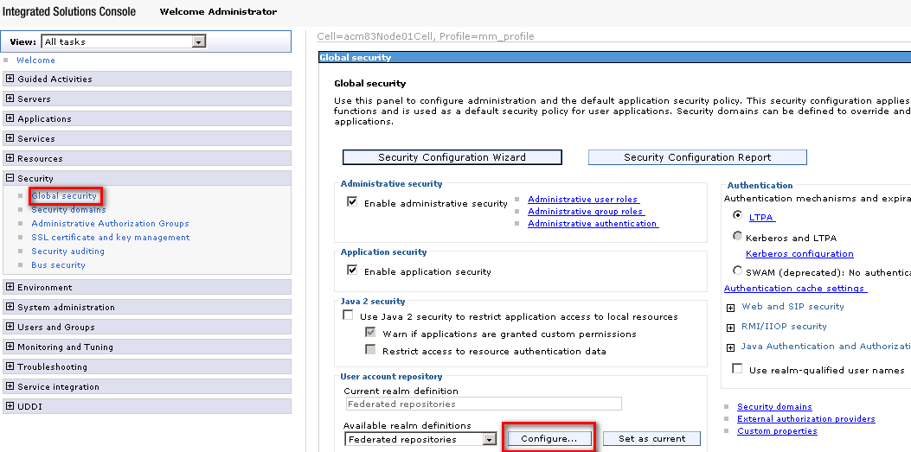

2.1 Click button Add Base entry to Realm…
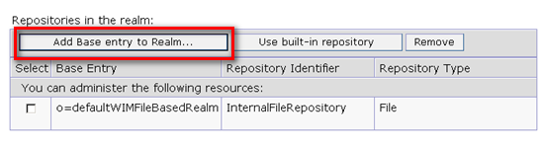
2.3 Click button Add Repository…
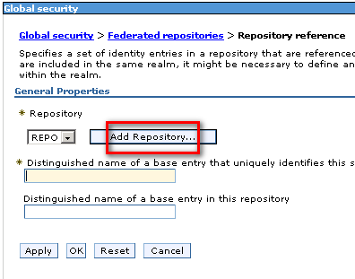

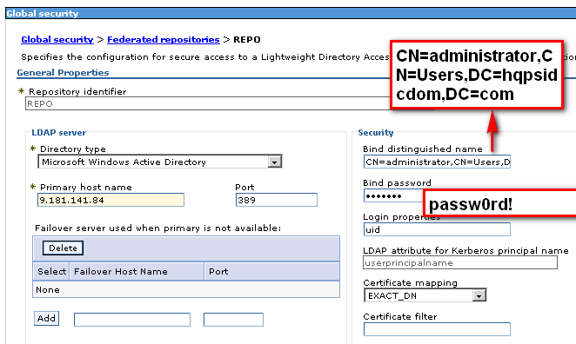

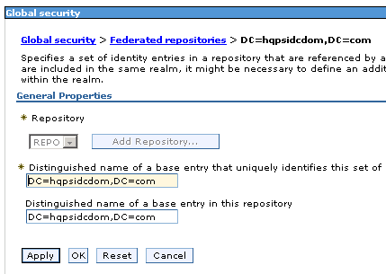

2.4 Save your changes to the master configuration.
2.5 Restart WAS , and log in the WAS console again to test whether you can log in the WAS console with the new password. Administrator/passw0rd!

Step 3. Install DB2 and Create database
Download: \\9.181.141.168\c$\Inatallers administrator/Passw0rd

- Install DB2 V9.7. Remember the user name and password.
- Copy sql script to your server to create database.
Sql script locate s at \\9.181.141.168\d$\DB2Scripts.168
- Create GCD DB for CE
  - Modify creategcddb.bat file
Here is an example if you want to create the database at C:\DB2
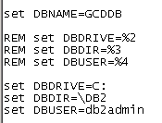
  - Run creategcddb.bat at command window.
- Create ADOS DB for Object Store ADOS
Here is an example if you want to create the database at D:\DB2
- Create ATOS DB for Object Store ATOS and PE
Here is an example if you want to create the database at D:\DB2

Step4. Install CE Server
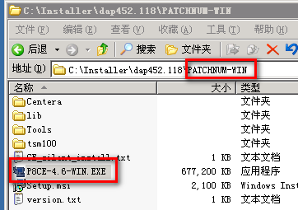
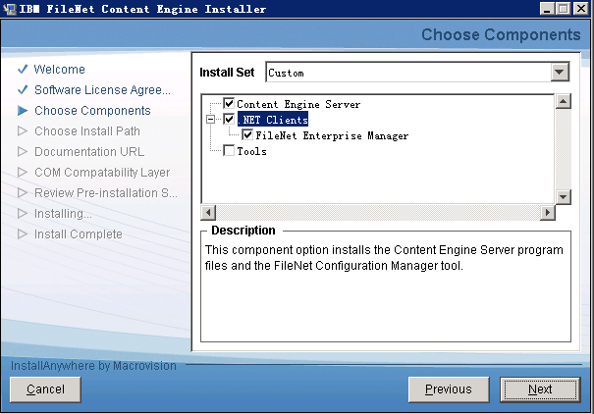
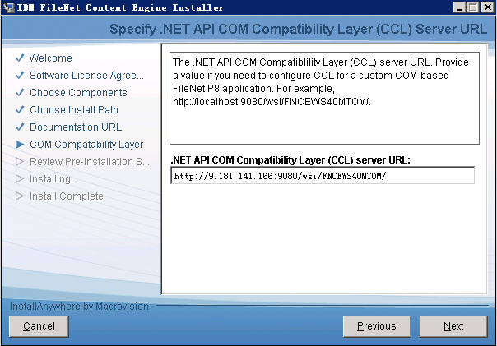
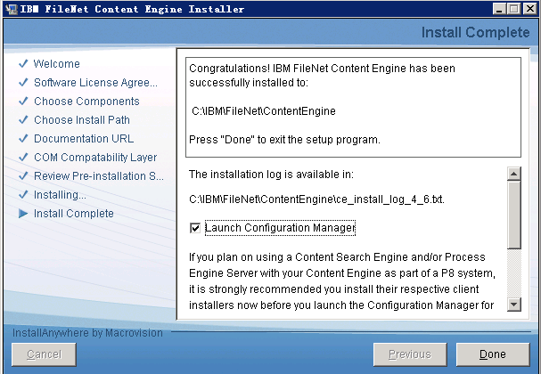

Step5. Config CE Servere

5.1 New Profile
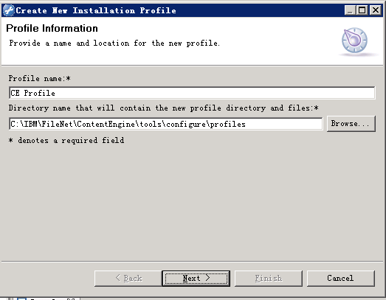
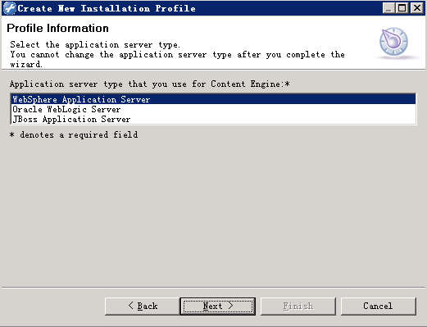
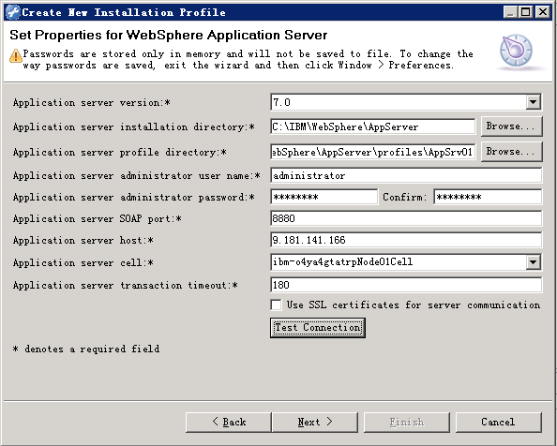
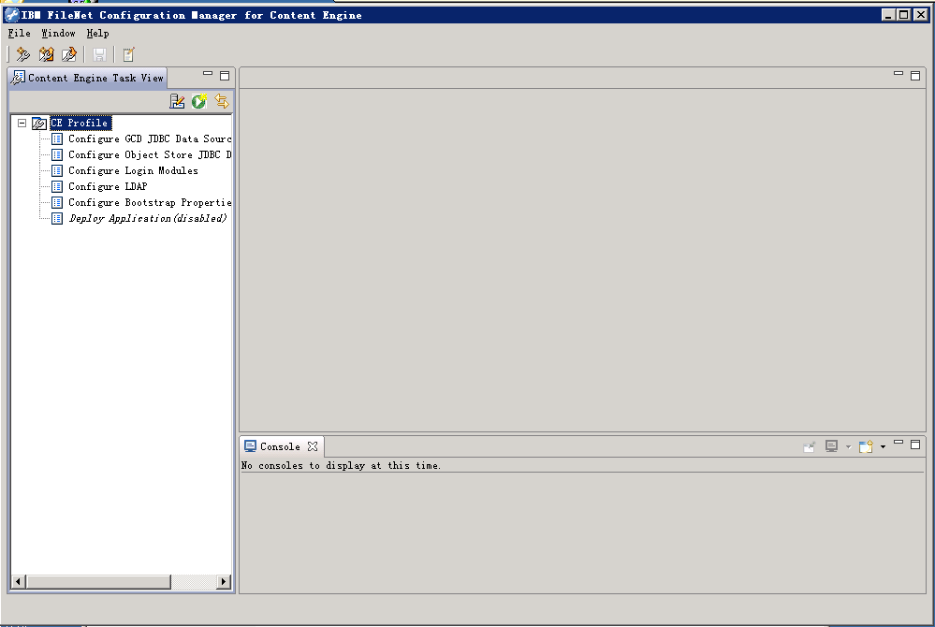

5.2 Run Task 1:

5.2.1 WAS Console
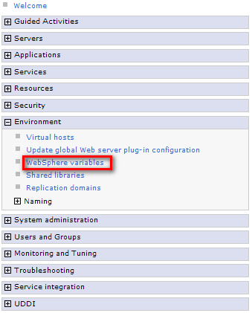
Select Cell
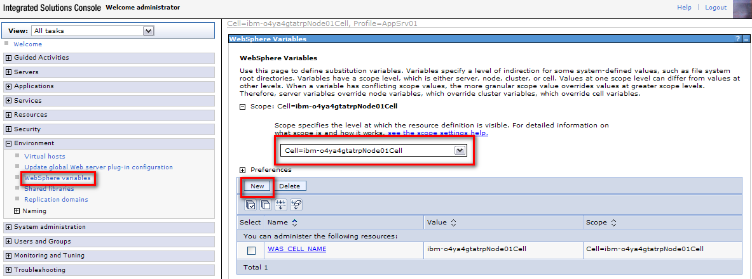

Add two
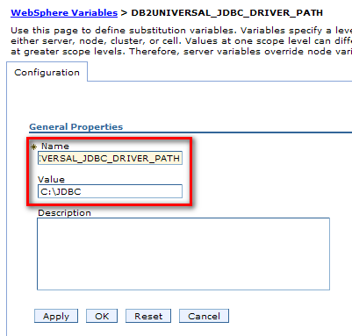
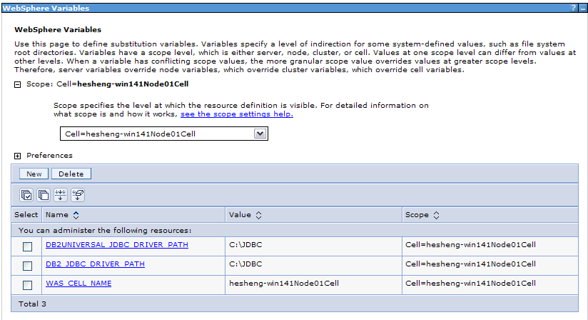

Select Node
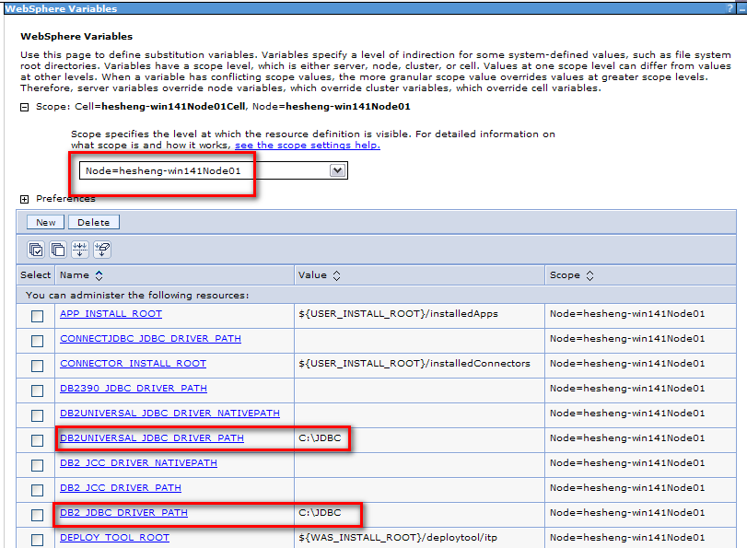

Restart WAS

Run task1
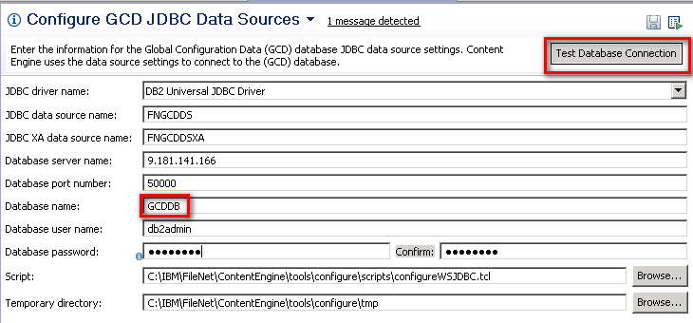

Test Connection On WAS Console
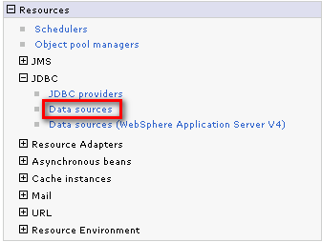
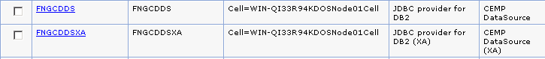

Run Task2:

5.3.1 Create Data Sources for ADOS
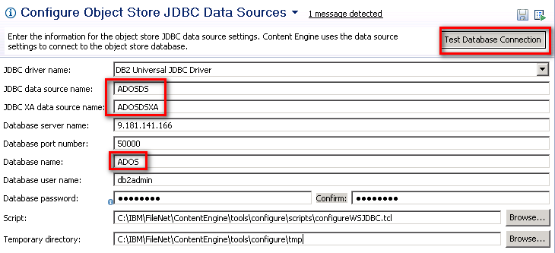

Test Connection On WAS Console

5.3.2 Create Data Sources for ATOS
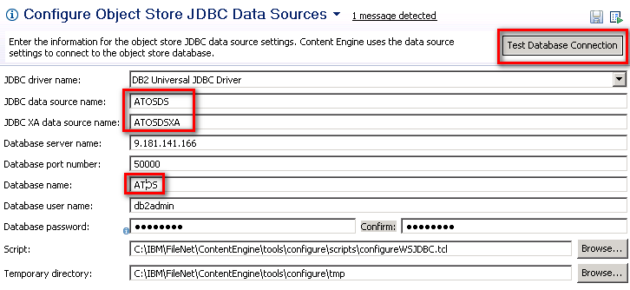

Test Connection On WAS Console

5.4 Run Task3:
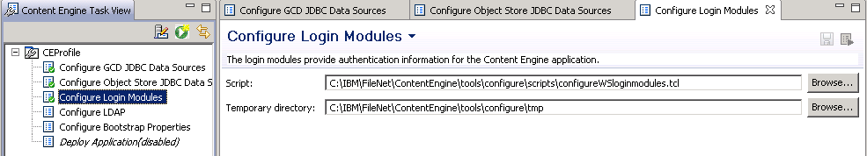

Validation：
Log in WAS console
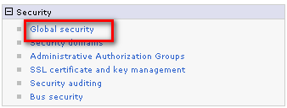
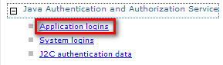
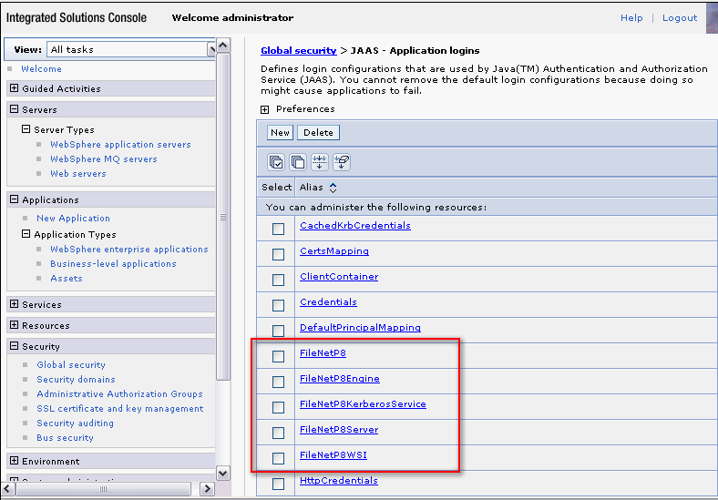

Skip Task 4: Config LDAP
Have already configured it on WAS.

Install PE Client at CE server
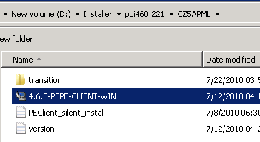

5.7 Run Task5:Configure Bootstrap Properties
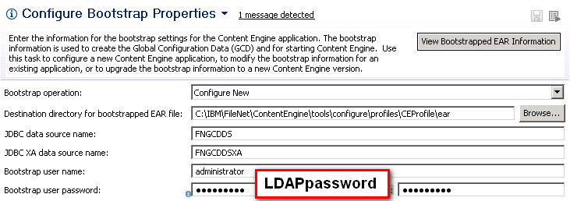

5.8 Run Task6: Deploy Application

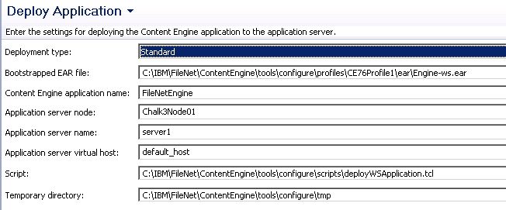

5.9 Restart WAS

Step 6. Validation
http://9.181.141.166:9080/wsi/FNCEWS40MTOM/
http://9.181.141.166:9080/FileNet/Engine

Step 7. Configure Domain
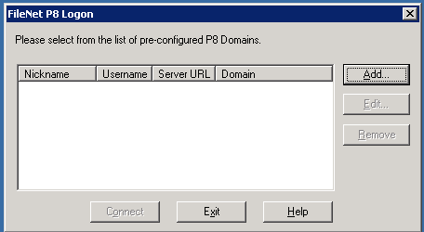
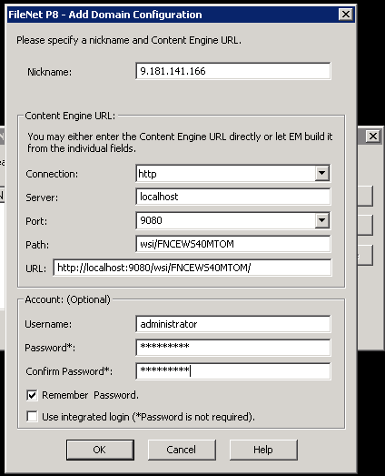
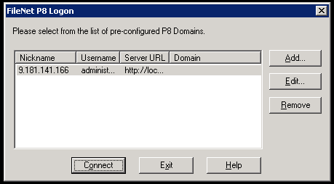
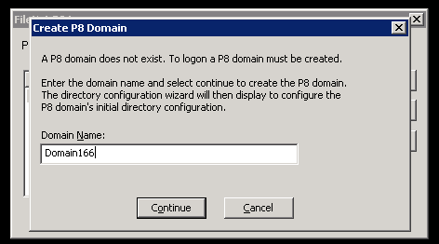
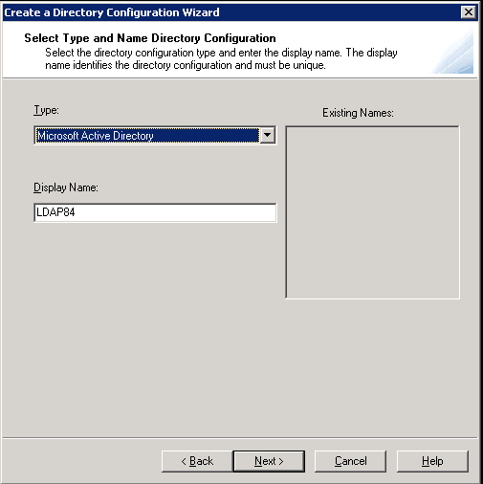

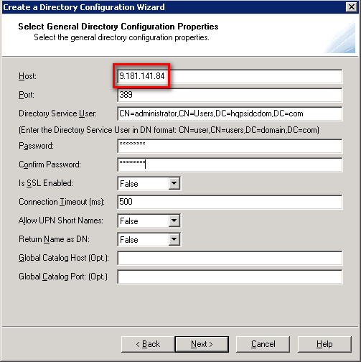

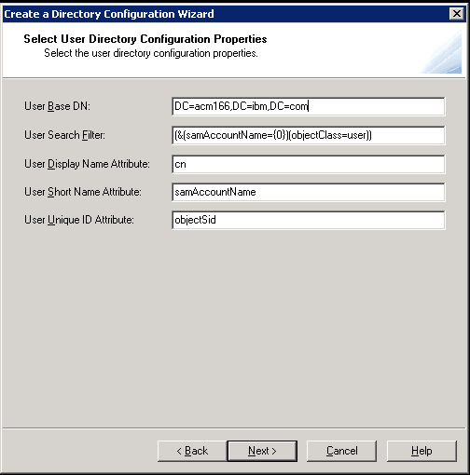

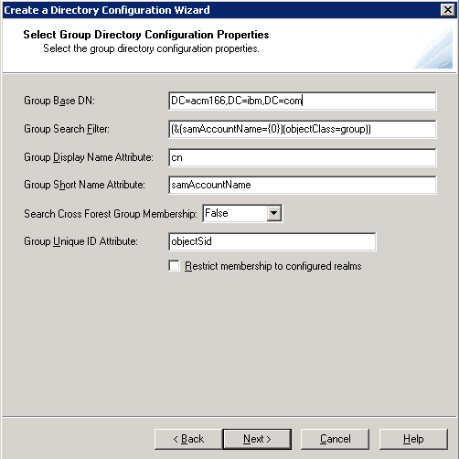
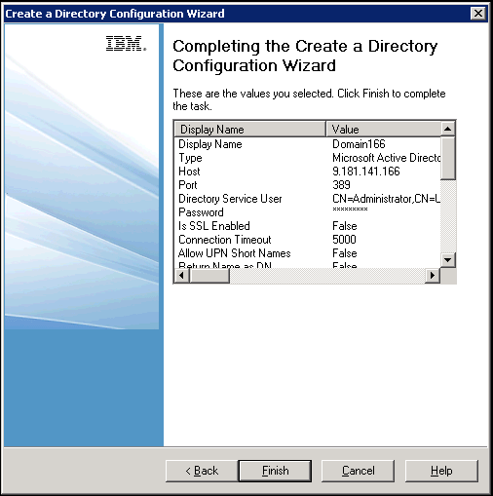

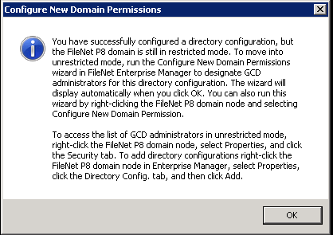

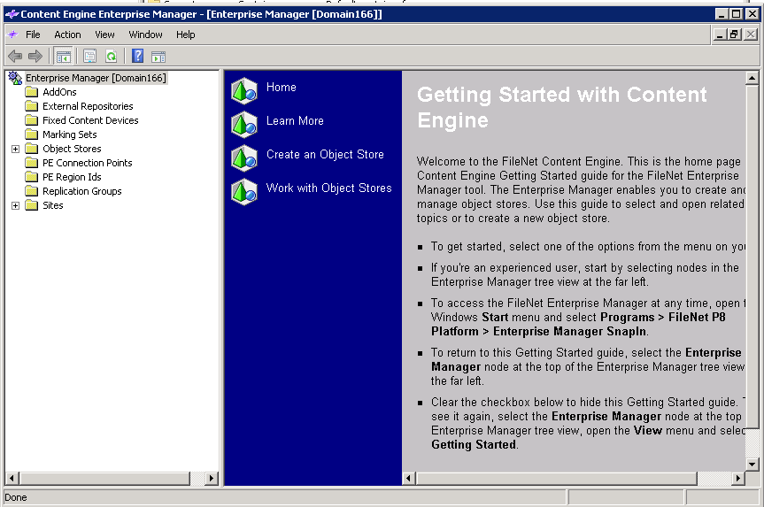

Step 8. Create Object Store ADOS
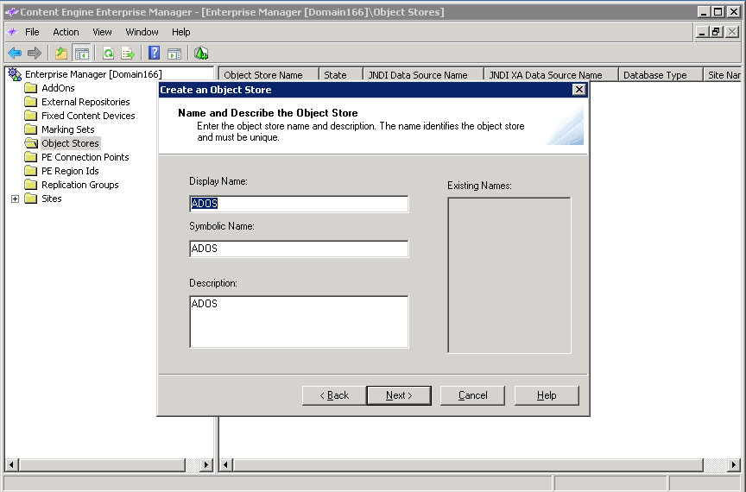
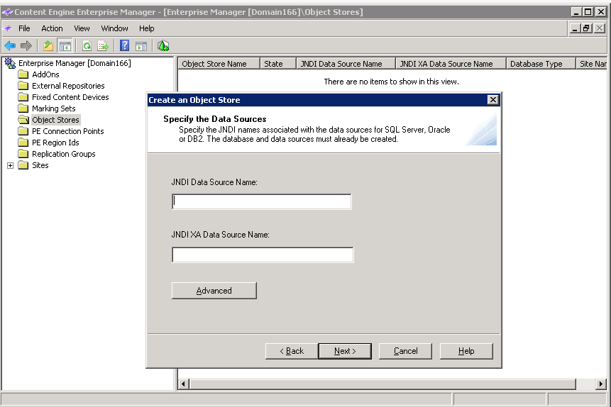

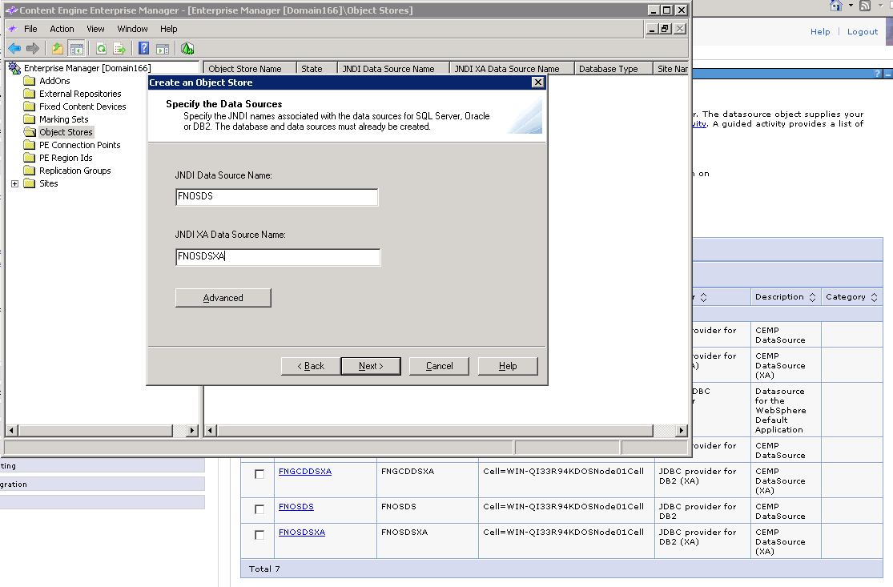
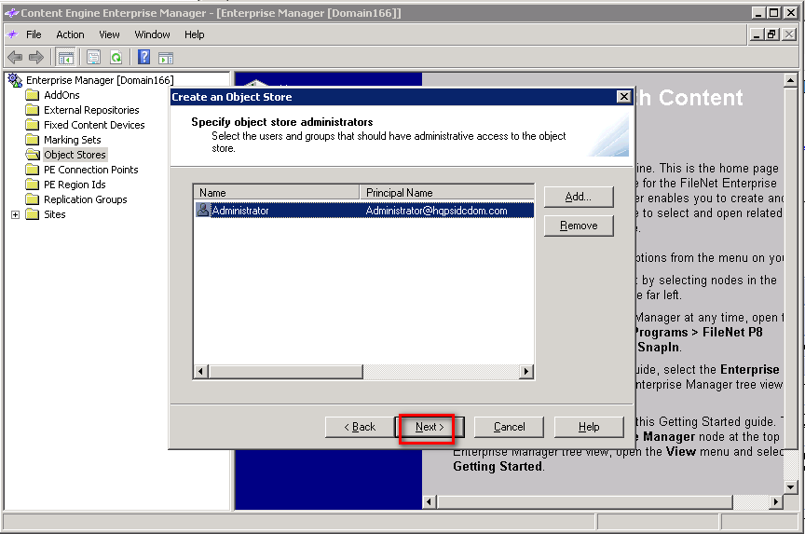

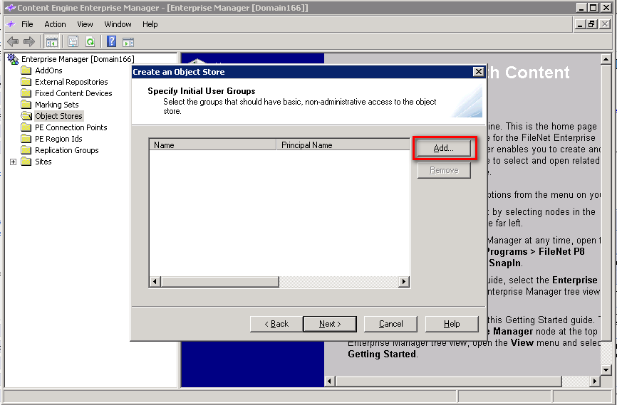

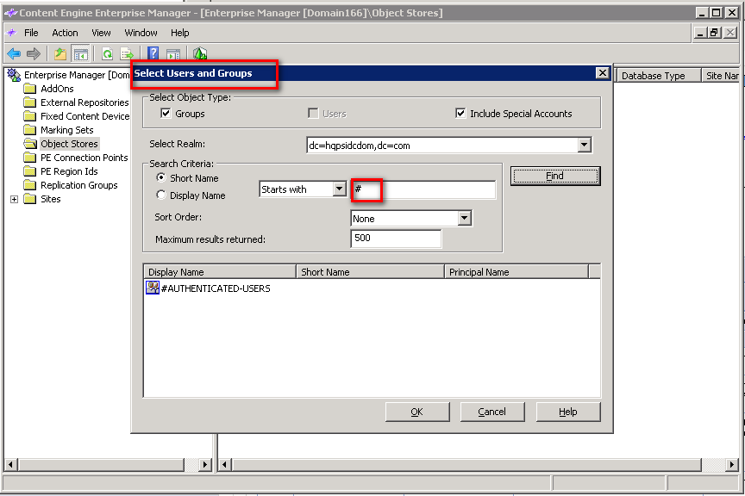

Find #

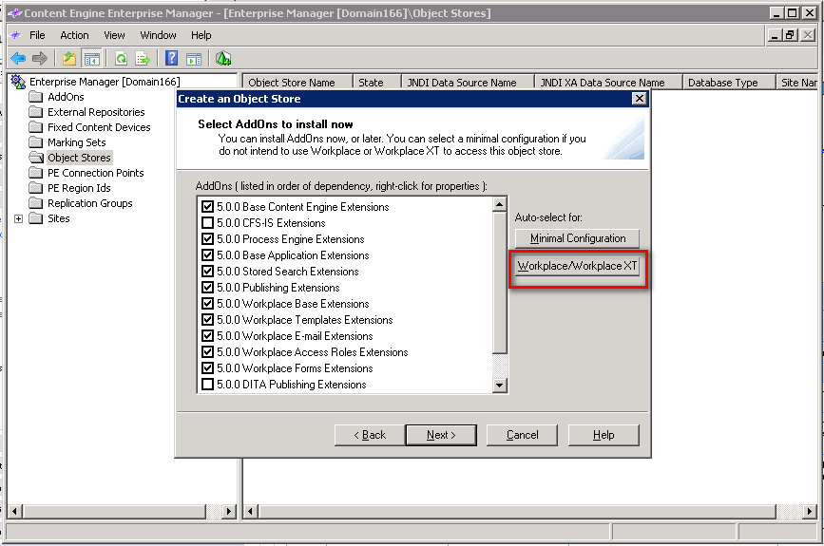
Click WorkplaceXT

Step 9. Create Object Store ATOS
It is the same way with creating ADOS

Install PE Server

Step1. Install PE build
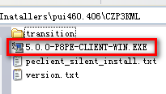

Step2. Install CE client
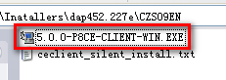

Step3. Modify the path for db2 jar
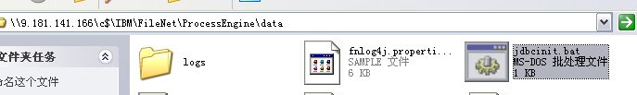
\c$\IBM\FileNet\ProcessEngine\data

Step 4. Configure PE
Launch Process Task Manager from Start-> All Programe ->IBM FileNet P8 Platform-> Process Engine
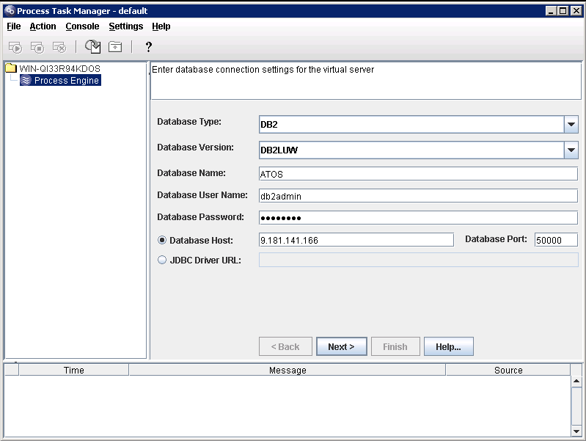
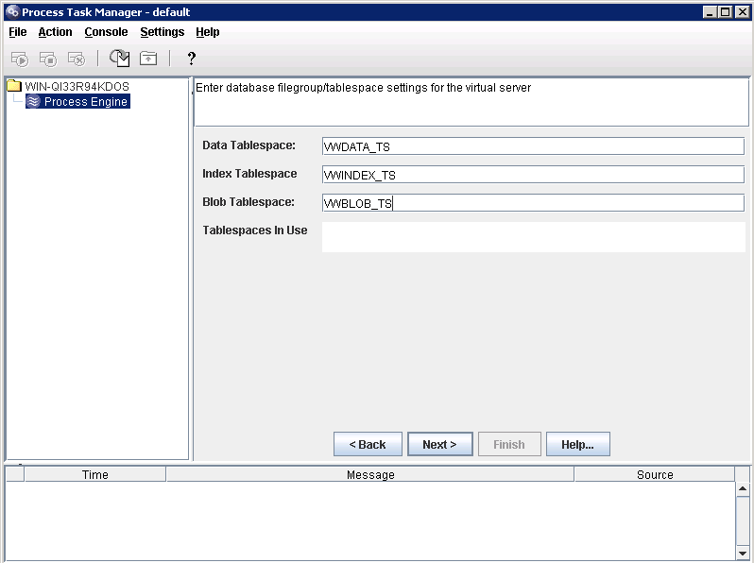
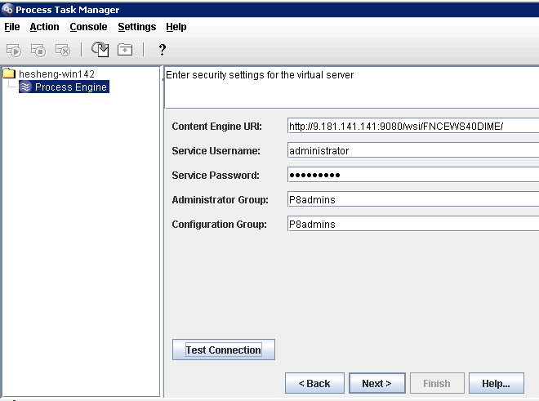
Test Connection.

Step 5. Validation
http://9.181.141.168:9080/wsi/FNCEWS40DIME/

Step 6. Create Connection Point
6.1 Create PE Region IDs at Content Engine Enterprise Manager
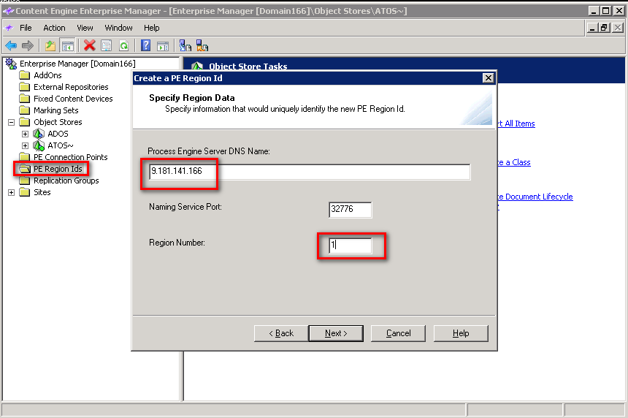

6.2 Create PE Connection Points
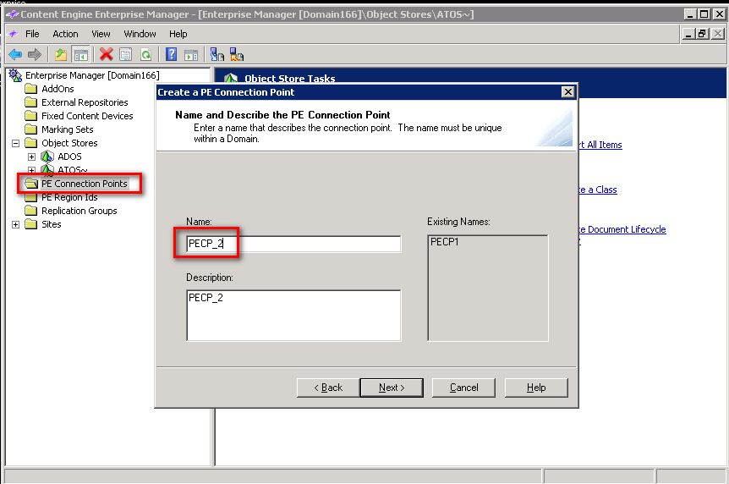

6.3 Create Regions on Process Task Manager
